**Project Report Format**

**Project Title: LearnHUb:Your Center For Skill Enhancement**

**1. INTRODUCTION**

**1.1 Project Overview**

LearnHub is an Online Learning Platform (OLP) designed to facilitate digital education for learners, instructors, and administrators. It enables course creation, enrollment, certification, and student-teacher interaction through a responsive and intuitive web application.

**1.2 Purpose**

The purpose of LearnHub is to provide flexible, accessible, and interactive learning for all users by leveraging modern web technologies and scalable infrastructure.

**2. IDEATION PHASE**

**2.1 Problem Statement**

Many learners face challenges in accessing quality education due to geographical, financial, or time constraints. Existing platforms are often too complex or costly for beginners.

**2.2 Empathy Map Canvas**

* **Says**: “I want to learn a new skill, but I don’t know where to start.”
* **Thinks**: “Will this course be worth my time and money?”
* **Does**: Searches YouTube or blogs for resources
* **Feels**: Confused, overwhelmed, and skeptical about learning online

**2.3 Brainstorming**

Ideas included:

* A self-paced learning portal
* Live webinars
* Affordable paid courses
* Certificate generation
* Instructor management
* Admin dashboard

**3. REQUIREMENT ANALYSIS**

**3.1 Customer Journey Map**

**User** → Registers → Searches Courses → Enrolls → Learns at Own Pace → Interacts with Instructor → Completes → Gets Certified

**3.2 Solution Requirements**

* Intuitive UI
* Secure authentication
* Course upload & management
* Certification engine
* Admin-level control
* Scalability

**3.3 Data Flow Diagram**

*Will be provided in the Appendix as a diagram.*

**3.4 Technology Stack**

* **Frontend**: React.js, Bootstrap, Material UI
* **Backend**: Node.js, Express.js
* **Database**: MongoDB Atlas
* **Auth**: JWT

**4. PROJECT DESIGN**

**4.1 Problem-Solution Fit**

The platform solves the need for accessible, flexible education with features like self-paced modules, teacher interaction, and certification.

**4.2 Proposed Solution**

LearnHub offers:

* Course browsing and filtering
* Instructor-led learning
* Progress tracking
* Certificates
* Paid & free course models

**4.3 Solution Architecture**

Follows a client-server model. React handles UI, Axios manages API calls, Express.js processes backend logic, and MongoDB stores structured data.

**5. PROJECT PLANNING & SCHEDULING**

**5.1 Project Planning**

* **Week 1**: Requirement Gathering & UI Design
* **Week 2**: Frontend Development
* **Week 3**: Backend & APIs
* **Week 4**: Database Integration
* **Week 5**: Testing & Debugging
* **Week 6**: Final Demo & Report

**6. FUNCTIONAL AND PERFORMANCE TESTING**

**6.1 Performance Testing**

* Load-tested API endpoints
* Verified response time for course search, login, and enrollment
* Tested with 100+ concurrent users on local setup

7.**RESULTS**

7.1Output:

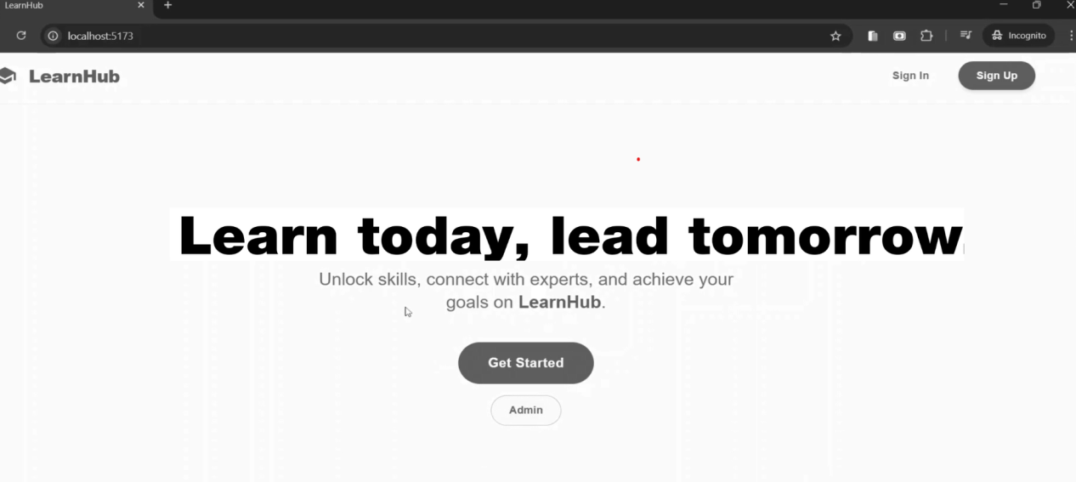

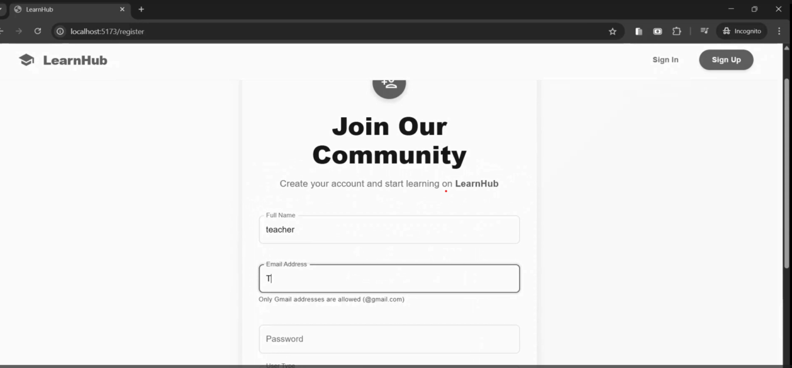

**8. ADVANTAGES & DISADVANTAGES**

**Advantages:**

* **User-friendly interface**
* **Self-paced and instructor-led learning**
* **Scalable and flexible**
* **Real-time interaction**

**Disadvantages:**

* **Requires stable internet connection**
* **No mobile app (currently web-only)**

**9. CONCLUSION**

**LearnHub bridges the gap between learners and instructors through an efficient, interactive platform. It demonstrates how modern tech can deliver impactful learning at scale.**

**FUTURE SCOPE 11. APPENDIX**

Source Code(if any)

Dataset Link

GitHub & Project Demo Link

https://drive.google.com/file/d/1ML1WtKYnvB_w2C54DrjFest6CfsUySbP/view?usp=sharing